AP Biology Name __________________________
Plant Response to Internal and External Signals
Guided Reading Chapter 39

- Label the important parts of signal transduction on this figure. Give an example of what a failure at each step might cause to happen within a cell or organism
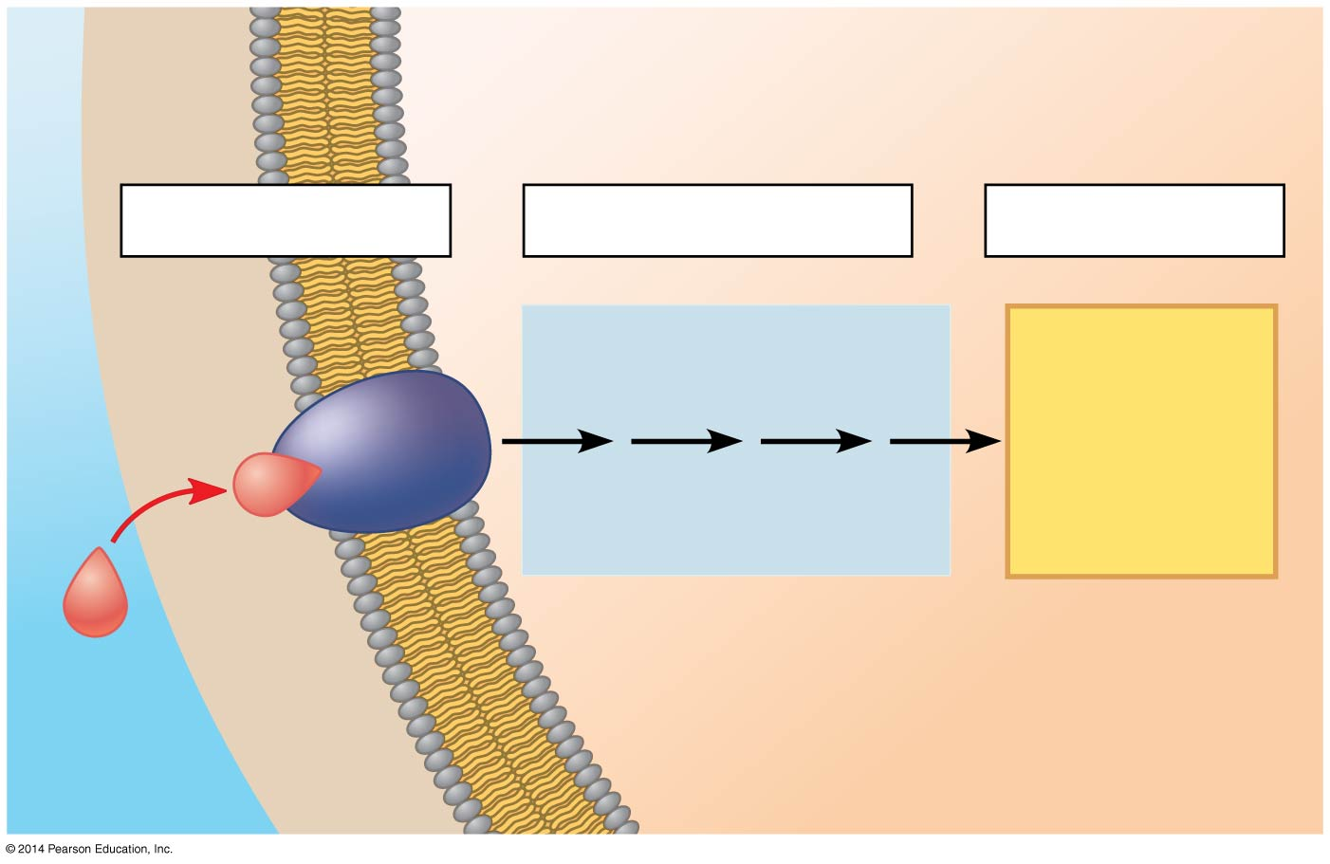
Step 1:

Step 2:

Step 3:
- Have you ever seen a shriveled potato sending out skinny, pale sprouts? What is this called? __________________________ What is a stimulus?

- If you move the potato into the light, the sprout will respond by forming short, sturdy stems and broad, green leaves. What is this response to light called?

- How do the potato’s morphological adaptations for growing in darkness increase its biological fitness?

- The following figure gives a specific example of a signal transduction in plants for the greening or de-etiolation response previously described. Label these parts of the figure: reception, transduction, response, phytochrome, signal Ca ²⁺ channel, second messenger (cGMP), protein kinase, transcription factor and DNA?
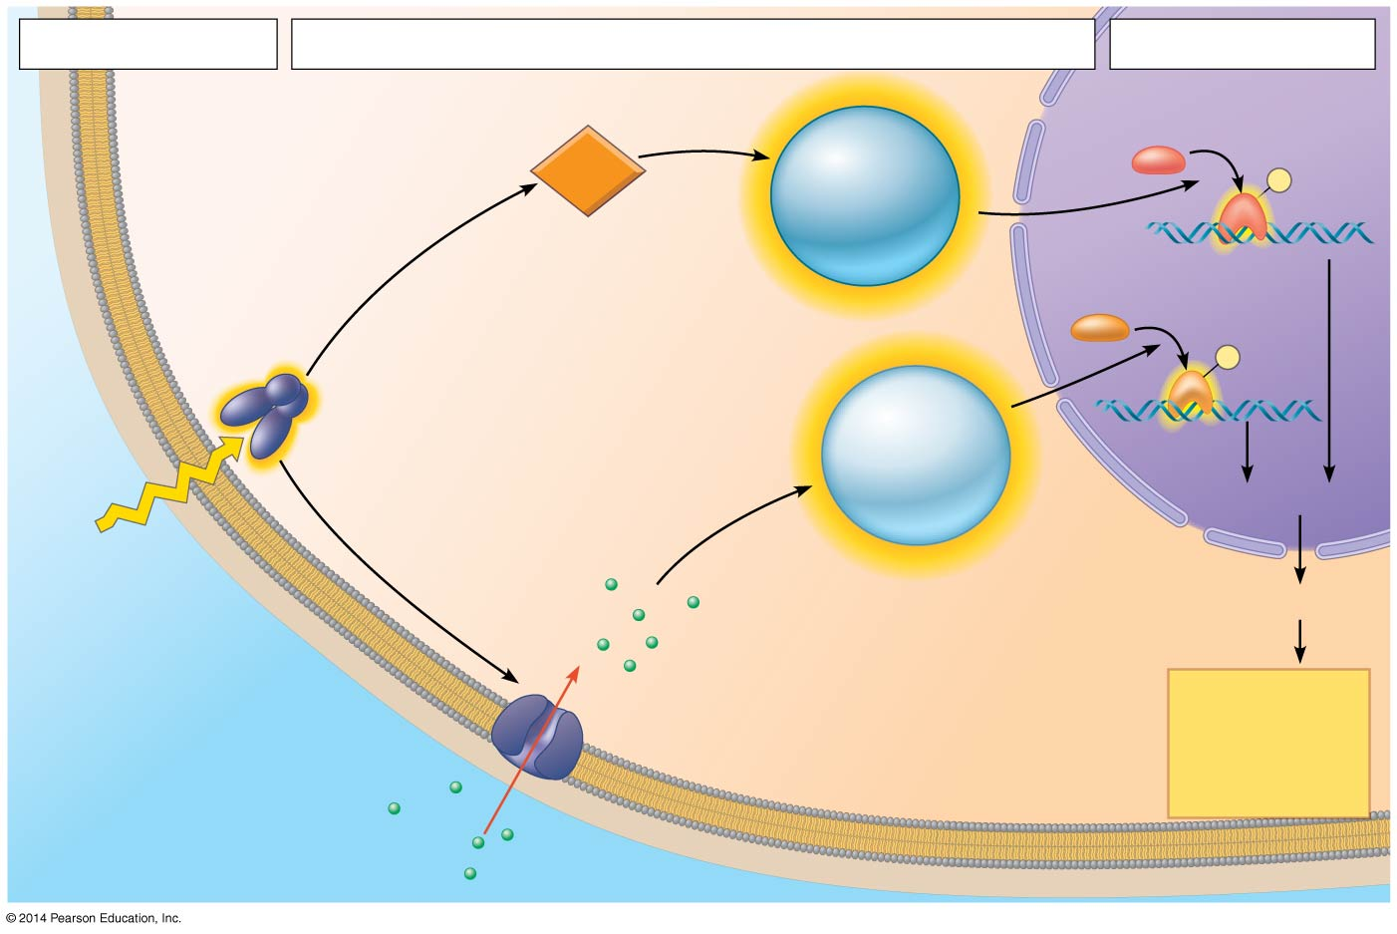

- Using the figure above: What is the signal? What occurs in transduction? Explain how the light signal causes the greening response. Number the steps, as shown in the figure in your text.
- What are the two second messengers in this pathway?
- Signal transduction pathways must also have a means for turning off when the initial signal is no longer present. What acts as an “off switch” and how does it work?
- (Read De-Etiolation Proteins) Give at least three specific ways in which proteins that are either activated or newly transcribed contribute to the process of greening.

- Both plants and animals have hormones. The original definition of a hormone has three parts. What are they?
- Many modern plant biologists think the term hormone as previously defined doesn’t quite fit plants. What term so they use instead?

- What is a tropism?

- The following sketch describes early experiments on phototropism conducted by Charles and Francis Darwin. What can be concluded from these experiments? Cite evidence that supports this conclusion.

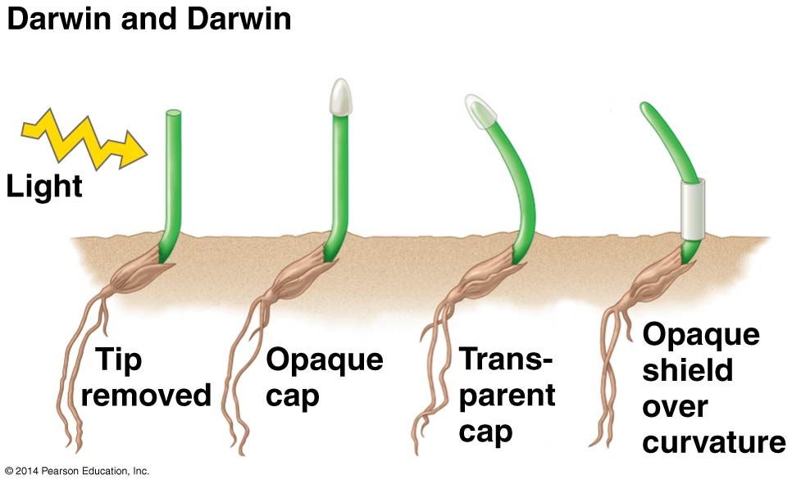

- Here is a sketch of the Boysen-Jensen experiment. What conclusions can be drawn from it?
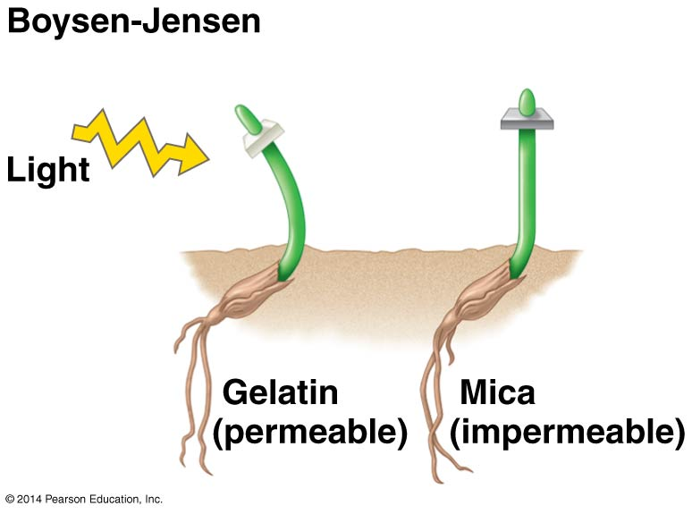
- Boysens_Jensen’s work was published in 1913. In 1926, Frits Went modified the experiment using agar cubes with a chemical from the coleoptile tips. The experiment is described on page 842 and shown below. Summarize what he did and explain his results.
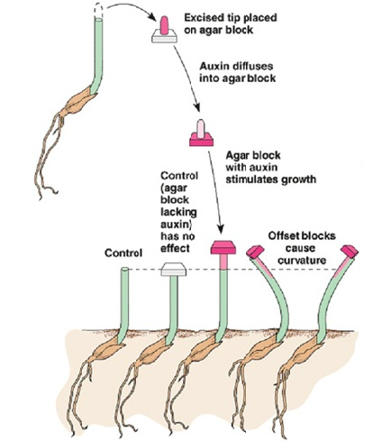

- What name did Went give to this chemical messenger? __________________ What was its chemical structure found to be?

- Fill out the following table:
Auxin Function | Description
- Did you catch the discussion of auxins as herbicides? Perhaps you have used Weed-B-Gon ® to kill dandelions in your lawn (or your parents have). Explain how this product kills dandelions without killing the grass.

- How did cytokinins get their name?

- All plant hormones are signaling molecules and can generate a wide range of cellular effects. In order to be familiar with this, fill out the following chart by selecting one function you think to be most important or interesting for each hormone.
Hormone | Major Function
Auxin
Cytokinins
Gibberellins (GA)
Abscisic acid (ABA)
Ethylene

- Ethylene is the only hormone in our group that is a gas. The functions of ethylene are many and varied. One that has practical application for your is that it promotes fruit ripening and senescence. That old phrase “one rotten apple can spoil the bunch” is true. Under what conditions is ethylene produced?

- Researchers have determined that plants have two major classes of light receptors. List each class.

- What wavelengths of light are absorbed by phytochromes?

- What are three different responses initiated by blue light?

- Read the description of how phytochromes work carefully. What is the wavelength of red light? _____________ Of far-red light? _______________

- Phytochromes are photoreceptors that have two isomer forms, P_{r} and P_{fr.} This figure shows the conversion of P_{r} and P_{fr.} and the reverse. What conditions maintain the phytochrome as P_{r} ?
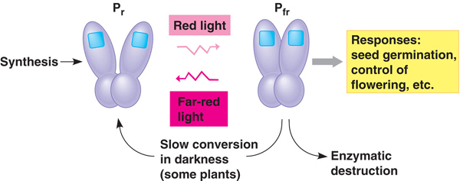

- What is the active form of phytochrome P_{r} or P_{fr} ? _____________

- Look again at the effect of light exposure on lettuce seed germination shown in Fig 39.16. What is the role or red and far-red light in determining the seed’s response?

- To make sense of all this, you will want to read carefully the Phytochromes and Shade Avoidance section. Which type of red light is more common in a shaded area? Why?

- What is a circadian rhythm? Give one plant example and one human example.

- How do phytochromes function in plant circadian rhythms?

- What is the photoperiod?

- Plants detect photoperiod, and in many species it affects their time of flowering. Explain each of the following, and give and example of a plant that is in the group.
  - Short-day plant

  - Long-day plant

  - Day-neutral plant

- Label R, FR, short-day plant, long-day plant and critical dark period.
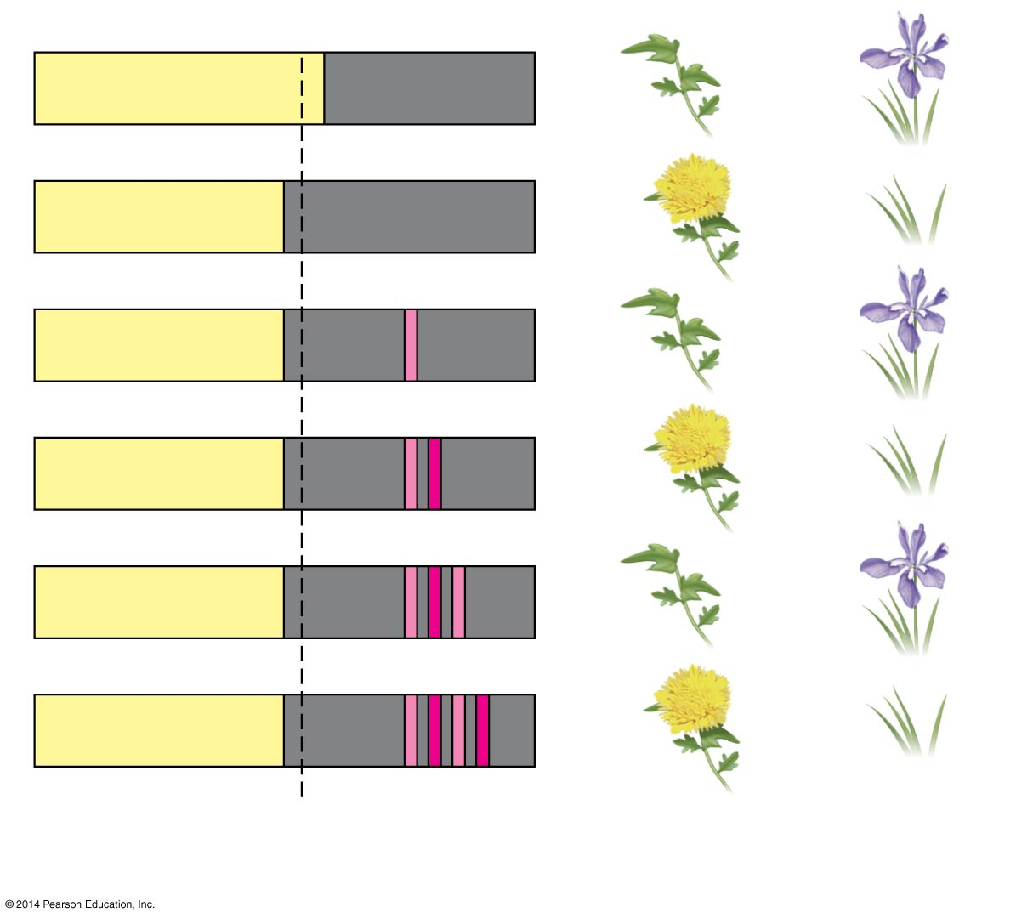
- What is gravitropism? How may a plant detect gravity?

- What is thigmotropism? How is it adaptive?

- List six different ways in which a plant responds to drought.

- Select any other stress situation besides water deficit, and explain plant mechanisms for dealing with this.

- Like animals, plants have immune responses. The first line of immune defenses is called PAMP-triggered immunity. How are the plant immune responses similar to vertebrate responses? Different?

- What occurs when PAMPs are recognized?

- Use Fig 39.27 to fill out the following table:

Level of Defense | Mode of Defense/Example
Molecular
Cellular
Tissue
Organ
Organismal
Population
Community

